INTERNSHIP REPORT

On

Full Stack Development Using MERN STACK

(Project: HOUSE HUNT: finding your perfect rental home)

submitted in partial fulfillment for the award of the degree of
BACHELOR OF TECHNOLOGY
Submitted by

ANISETTI MAHESH Frontend
TRIVENI MEDEPALLI Backend
SWARJAN VATTIPALLI Framework
MEDHA PRANATHI PARIMI Database

Under the Supervision of
SmartBridge Educational Services Pvt. Ltd.
In collaboration with
Andhra Pradesh State Council of Higher Education (APSCHE)



Internship Duration: Dec 2025 – Feb 2026
Academic Year: 2025 – 2026
CHAPTER 1
INTRODUCTION

1.1 Project Overview

HouseHunt – Finding Your Perfect Rental Home is a Full Stack Web Application developed to simplify and modernize the rental property searching process. In today’s fast-paced digital world, finding a suitable rental home through traditional methods can be time-consuming and inefficient. HouseHunt provides a centralized online platform where users can easily explore available rental properties based on their preferences.
The platform allows users to:
- Browse rental property listings
- Search properties by location
- Filter based on price range, property type, and amenities
- View detailed property descriptions with images
- Contact property owners directly through the system
The application is developed using modern web technologies:
- Frontend: React.js (for interactive and responsive UI)
- Backend: Node.js and Express.js (for server-side logic and APIs)
- Database: MongoDB (for storing user and property data securely)
The system ensures secure user authentication using JWT-based login/signup functionality. It also includes an Admin Panel to manage users, property listings, and overall platform operations.
The main objective of this project is to create a reliable, efficient, and centralized digital solution for rental property search and management, reducing manual effort and improving user experience.

1.2 Purpose

The purpose of this project is:
- To eliminate the traditional manual house searching process
- To provide real-time rental property listings
- To enable easy filtering and property comparison
- To ensure secure user authentication and data protection
- To provide an efficient admin management system
- To reduce time and effort required to find rental homes
- To create a transparent platform connecting tenants and property owners
- To improve accessibility through a responsive web interface
- To maintain accurate and up-to-date property information

CHAPTER 2
IDEATION PHASE

2.1 Problem Statement

In modern urban environments, finding a suitable rental home has become increasingly complex and time-consuming. Tenants often struggle due to the lack of a centralized platform where all rental property information is available in one place. Most property searches rely on brokers, social media posts, or unverified advertisements, which leads to incomplete or misleading information. Physical visits to multiple properties consume significant time and effort, especially when property details such as pricing, amenities, and availability are not clearly disclosed in advance.
Additionally, communication gaps between tenants and property owners create further inconvenience. Many listings lack accurate contact details, and responses are often delayed or unclear. There is also no structured digital system to manage rental listings efficiently, which increases the risk of fake advertisements, hidden charges, and fraud. Because of these challenges, there is a strong need for a centralized online rental property platform that enables easy property search, advanced filtering, verified listings, and direct communication between tenants and owners in a secure and transparent environment.

2.2 Empathy Map Canvas

The Empathy Map was created to understand the mindset, emotions, and behaviour of users searching for rental homes. From the user’s perspective, they primarily think about affordability, authenticity, and convenience. A typical user wants housing that fits their budget, expects genuine property listings, and desires quick communication with property owners without unnecessary intermediaries.
Emotionally, users often feel frustrated with brokers due to high commissions and lack of transparency. They may feel confused about pricing variations in different areas and worried about potential fraud or hidden costs. These emotions influence their decision-making process and increase the importance of trust and transparency in a rental platform.
When expressing their needs, users usually say that they want a simple and easy-to-use interface, along with verified and trustworthy property listings. Their actions typically involve searching for properties online, comparing prices across platforms, and contacting multiple owners to gather more information before making a decision.
The major pain points identified include fake listings, hidden charges, delayed responses from property owners, and lack of clear property details. On the other hand, users expect gains such as an easy search process, transparent pricing information, reliable property details, and direct communication without broker interference. Understanding these insights helped shape the features and structure of the House Hunt platform.

2.3 Brainstorming
During the brainstorming phase, multiple solution approaches were analyzed to determine the most effective system design. Initially, the idea of developing a mobile-only application was considered, as smartphones are widely used and mobile apps provide better user engagement. However, this approach would limit accessibility for users who prefer desktop browsing and would require additional development resources.
The concept of building a website-only platform was also evaluated. While a web application ensures accessibility across devices, it needed to be modern, responsive, and scalable to handle future enhancements. Another option considered was developing a hybrid application that could function both as a mobile app and a website. Although this approach offered flexibility, it increased development complexity and maintenance cost.
A broker management system was also discussed as an alternative solution. However, this model still relied heavily on intermediaries and did not fully eliminate the problems of transparency and direct communication.
After analyzing feasibility, scalability, cost, and user accessibility, the final decision was to develop a Full Stack Web Application using the MERN Stack (MongoDB, Express.js, React.js, and Node.js). The MERN Stack was selected because it is highly scalable, cost-effective, and allows seamless integration between frontend and backend. It supports responsive design, efficient data management, secure authentication, and future enhancements such as payment integration and AI-based recommendations. This approach ensures that the platform is accessible on all devices while maintaining performance and reliability.

2.4 Solution Approach
Based on the problem analysis, empathy mapping, and brainstorming discussions, a structured solution approach was designed to address the challenges in the rental housing system. The primary goal was to build a centralized, secure, and user-friendly platform that connects tenants and property owners directly without unnecessary intermediaries.
The proposed solution is the development of a Full Stack Web Application named House Hunt – Finding Your Perfect Rental Home using the MERN Stack architecture. The platform is designed to provide a seamless experience where users can register, log in securely, search for rental properties based on customized filters, and directly contact property owners. Property owners can create and manage listings by adding complete property details, uploading images, updating availability status, and responding to tenant inquiries.
To ensure efficiency and scalability, the application follows a three-tier architecture consisting of the frontend, backend, and database layers. The frontend, developed using React.js, provides an interactive and responsive user interface. The backend, built with Node.js and Express.js, handles business logic, API requests, authentication, and authorization processes. MongoDB is used as the database to store user profiles, property listings, and system data securely.
Security is implemented using JWT-based authentication to protect user data and restrict unauthorized access. The system also includes an admin panel that allows administrators to monitor listings, manage users, and remove inappropriate or fake property advertisements.
The solution emphasizes transparency, ease of use, and reliability. By providing structured property data, advanced search filters, and direct communication features, House Hunt reduces time consumption, eliminates hidden costs, and minimizes fraud risks. The platform is designed to be scalable, allowing future enhancements such as online rent payment integration, review and rating systems, notification services, and AI-based property recommendations.
This solution effectively addresses the identified problems and provides a modern digital approach to rental property management.

CHAPTER 3
REQUIREMENT ANALYSIS

3.1 User Flow
The House Hunt system is designed to provide a smooth and intuitive user experience by following a structured workflow. The process begins with user registration and login, where new users create an account by providing basic details, and existing users authenticate using secure credentials. This authentication mechanism ensures secure access to personalized features.
After successful login, users can browse available rental properties displayed on the home page. The platform presents property listings in a structured and visually appealing format, allowing users to quickly scan essential details such as price, location, and property type.
To make the search process efficient, users can apply filters based on their specific requirements, such as location, budget range, and type of property. The filtering system dynamically updates the displayed results without reloading the entire page, enhancing performance and user convenience.
When a user selects a property, they can view detailed information including property description, amenities, rental price, images, and owner contact details. This detailed view ensures transparency and reduces unnecessary physical visits.
Users can directly contact the property owner through the platform to clarify doubts or arrange visits. Additionally, the system provides a save property feature, allowing users to add properties to their favourites list for future reference. This structured user flow ensures a seamless and efficient rental search experience.

3.2 Solution Requirements
Functional Requirements
The functional requirements define the core features and operations of the system. The House Hunt platform must allow users to register and create accounts securely. Login authentication must validate user credentials and provide authorized access to the system.
The system should display property listings dynamically from the database and allow users to search and filter properties based on various criteria. Users must have the ability to add properties to their favourites list for later comparison.
An admin login module is required to provide administrative control over the platform. The admin should be able to add new properties, edit existing listings, and delete inappropriate or outdated property data. The system must also allow property owners to manage their listings efficiently.
Non-Functional Requirements
Non-functional requirements define the quality and performance aspects of the system. The application must load quickly and provide smooth navigation without delays. Secure authentication mechanisms such as JWT must be implemented to protect user data.
The user interface must be responsive and adaptable to different screen sizes, including desktops, tablets, and smartphones. The architecture must be scalable to accommodate increasing numbers of users and property listings in the future without affecting performance.

3.3 Data Flow Diagram (DFD Explanation)
The HouseHunt system follows a structured data flow process to ensure smooth communication between different components. When a user interacts with the system, the request is first handled by the frontend developed in React.js. The frontend sends API requests to the backend server built using Node.js and Express.js.
The backend processes the request and interacts with the MongoDB database to retrieve or store data. After fetching the required information, the backend sends the response back to the frontend, where it is dynamically displayed to the user.
For example, when a user searches for a property, the search request is sent to the backend. The backend queries the MongoDB database to fetch matching property records. The retrieved data is then returned to the frontend and displayed in a structured format. This bidirectional data flow ensures accurate and real-time information delivery.
The overall data flow can be summarized as:
User → React Frontend → Node.js Backend → MongoDB Database → Backend → Frontend → User
This architecture ensures separation of concerns, better performance, and maintainability.

3.4 Technology Stack
The House Hunt platform is developed using modern web technologies to ensure performance, scalability, and maintainability.
The frontend is developed using HTML and CSS for structure and styling, along with Bootstrap for responsive design components. React.js is used to create dynamic and interactive user interfaces, manage components, and handle state efficiently.
The backend is developed using Node.js as the runtime environment and Express.js as the web framework. This combination allows the creation of RESTful APIs, handling server-side logic, and managing authentication and authorization.
MongoDB is used as the database to store user details, property listings, and system data. It is a NoSQL database that provides flexible schema design and efficient data handling.
For development and testing purposes, Visual Studio Code is used as the code editor. Git is used for version control and source code management. Postman is used to test API endpoints and ensure proper communication between frontend and backend.
This technology stack ensures that the House Hunt system is modern, efficient, scalable, and suitable for real-world deployment.

The data flow in the system works as follows:
- User → Frontend (React) → Backend (Node.js & Express.js) → MongoDB Database → Backend → Frontend → User

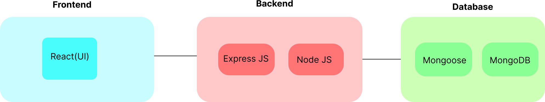

CHAPTER 4
PROJECT DESIGN

4.1 Problem Solution Fit
The traditional house-hunting process is largely manual, unstructured, and inefficient. Tenants often depend on brokers, newspaper advertisements, or informal online posts to find rental properties. This approach results in incomplete property information, unnecessary travel for physical visits, communication delays, and additional brokerage costs. Moreover, the absence of a centralized system increases the risk of fake listings and hidden charges, making the rental process stressful and unreliable.
House Hunt directly addresses these challenges by providing a structured digital platform that connects tenants and property owners without intermediaries. By centralizing rental listings and enabling direct communication, the system reduces time consumption, enhances transparency, and minimizes fraud risks. The platform ensures that property information is organized, searchable, and accessible in real time. This strong alignment between the identified problems and the provided solution establishes an effective problem–solution fit, making House Hunt a practical and impactful system for modern rental management.

4.2 Proposed Solution
The proposed solution is the development of a web-based rental property management platform that simplifies the process of searching, listing, and managing rental homes. The system is designed to provide a secure and user-friendly environment where tenants can search for properties and property owners can manage listings efficiently.
The platform includes a secure login and authentication system to ensure authorized access and protect user data. Real-time property listings allow users to view updated information regarding availability, pricing, and property details. Advanced filtering options enable users to refine their search based on location, price range, and property type, making the search process faster and more efficient.
Additionally, the system includes an admin dashboard that provides centralized control over the platform. The administrator can monitor user activities, manage property listings, remove fake or inappropriate content, and maintain overall system integrity. This structured approach ensures transparency, reliability, and smooth platform operation.

4.3 Solution Architecture
The HouseHunt system follows a Three-Tier Architecture model to ensure scalability, maintainability, and high performance. This architecture separates the system into three distinct layers, each responsible for specific functions.
The Presentation Layer is developed using React.js and is responsible for handling user interaction. It manages the user interface, displays property listings, processes form inputs, and communicates with the backend through API calls. This layer ensures a responsive and dynamic user experience.
The Application Layer is built using Node.js and Express.js. This layer contains the business logic of the system, processes user requests, manages authentication and authorization, and interacts with the database. It acts as a bridge between the frontend and the data layer, ensuring secure and efficient data handling.
The Data Layer uses MongoDB as the database system. It stores user information, property listings, authentication details, and administrative data. MongoDB’s flexible schema design allows efficient storage and retrieval of structured and semi-structured data.
By implementing this three-tier architecture, the system achieves better scalability, improved
CHAPTER 5

PROJECT PLANNING & SCHEDULING

5.1 Project Planning
- The project was developed in phases:
Phase 1 – Requirement Analysis
- Identified problem statement
- Defined system requirements
Phase 2 – System Design
- Designed database schema
- Planned frontend and backend structure
Phase 3 – Backend Development
- Created APIs
- Implemented authentication
- Connected MongoDB database
Phase 4 – Frontend Development
- Developed UI components
- Integrated APIs
- Implemented routing
Phase 5 – Testing
- Tested login system
- Verified order placement
- Checked admin functionalities
Phase 6 – Deployment and Documentation
- Finalized project
- Prepared documentation
- This structured planning ensured systematic development.

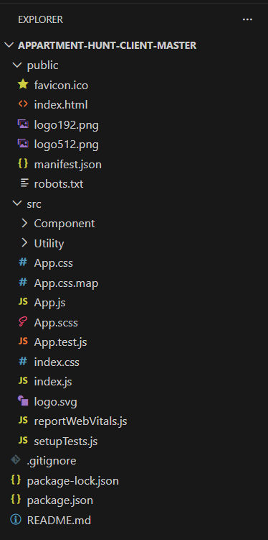
This structure assumes a React app and follows a modular approach. Here's a brief explanation of the main directories and files:
    - src/components: Contains components related to the application such as, register, login, home, etc.,
    - src/pages has the files for all the pages in the application.

PROJECT SETUP AND CONFIGURATION:
Install required tools and software:
- Node.js.
Reference Article: https://www.geeksforgeeks.org/installation-of-node-js-on-windows/
- Git.
Reference Article: https://git-scm.com/book/en/v2/Getting-Started-Installing-Git
Create project folders and files:
• Client folders.
• Server folders
Referral Video Link: https://drive.google.com/file/d/1uSMbPIAR6rfAEMcb_nLZAZd5QIjTpnYQ/view?usp=sharing
Referral Image:
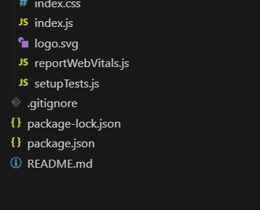
This structure assumes a React app and follows a modular approach. Here's a brief explanation of the main directories and files:
    - src/components: Contains components related to the application such as, register, login, home, etc.,
    - src/pages has the files for all the pages in the application.

PROJECT SETUP AND CONFIGURATION:
Install required tools and software:
- Node.js.
Reference Article: https://www.geeksforgeeks.org/installation-of-node-js-on-windows/
- Git.
Reference Article: https://git-scm.com/book/en/v2/Getting-Started-Installing-Git
Create project folders and files:
• Client folders.
• Server folders
Referral Video Link: https://drive.google.com/file/d/1uSMbPIAR6rfAEMcb_nLZAZd5QIjTpnYQ/view?usp=sharing
Referral Image:

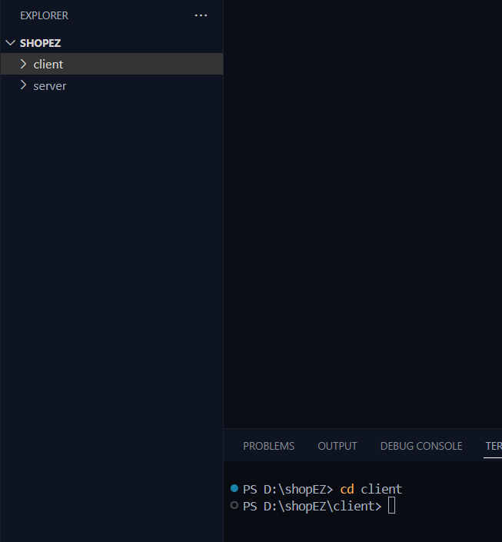

DATABASE DEVELOPMENT:

Create database in cloud video link:- https://drive.google.com/file/d/1CQil5KzGnPvkVOPWTLP0h-Bu2bXhq7A3/view
    - Install Mongoose.
    - Create database connection.
Reference Video of connect node with mongoDB database: https://drive.google.com/file/d/1cTS3_-EOAAvDctkibG5zVikrTdmoY2Ag/view?usp=sharing
Reference Article: https://www.mongodb.com/docs/atlas/tutorial/connect-to-your-cluster/

5.2 Project Structure Overview
The above image represents the frontend project structure of the Apartment Hunt application developed using React.js. The project follows a well-organized folder hierarchy generated using Create React App. The “public” folder contains static files such as index.html, favicon, logos, and manifest.json, which are directly served to the browser. The index.html file acts as the root HTML template where the React application is mounted.
The “src” folder contains the main source code of the application. It includes components, utility files, styling files such as App.css and App.scss, and the main entry files like App.js and index.js. The src folder is the core working directory where all UI components and business logic are implemented.
Additionally, configuration files such as package.json manage project dependencies, scripts, and libraries required for development. The structured organization improves maintainability, scalability, and efficient development of the web application.

Referral Image:

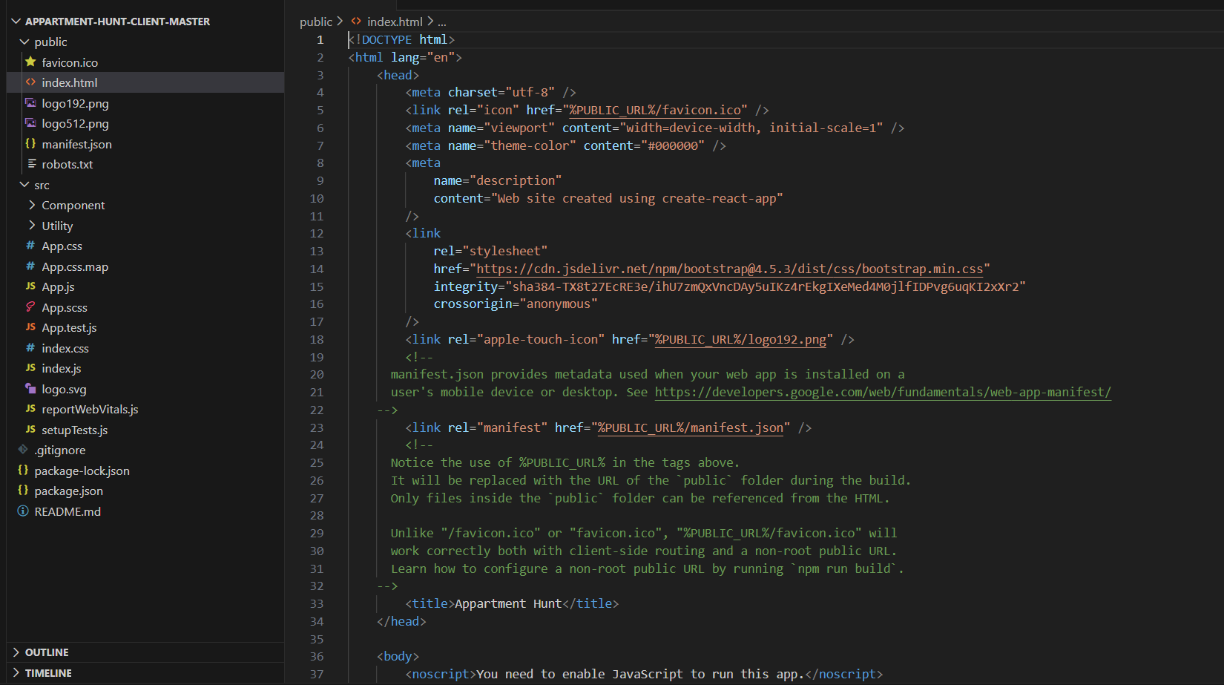

5.3 Web App Configuration (Manifest File)
The above image shows the manifest.json file located inside the public folder of the React application. This file contains metadata that defines how the web application behaves when installed on a user’s device. It plays an important role in enabling Progressive Web App (PWA) features.
The manifest file specifies the short name and full name of the application, which are displayed when the app is installed on mobile or desktop. It also defines application icons in different sizes such as 64x64, 192x192, and 512x512 pixels to ensure proper display across various devices and screen resolutions.
Additionally, properties like start_url determine the initial page when the app launches, while display set to “standalone” allows the application to run like a native app without the browser UI. The theme_color and background_color define the appearance of the application’s interface and splash screen.
This configuration enhances user experience by making the web application installable, responsive, and visually consistent across platforms.

Referral Image:

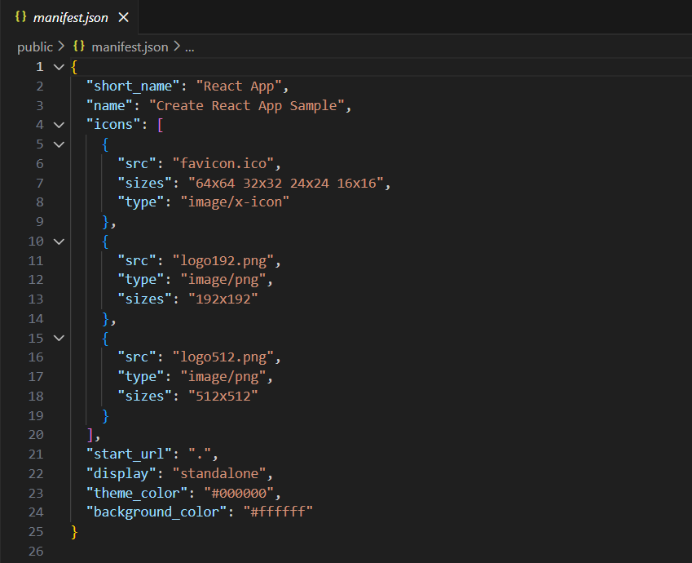

5.4 ApartmentDetails Component
The component uses React hooks to manage state and lifecycle behavior. The route parameter is extracted dynamically, allowing the application to identify which apartment details should be displayed. Once the component loads, it sends a request to the backend server to retrieve the specific apartment data associated with the given ID.
The retrieved data is stored in the component’s state and rendered dynamically on the page. Since the response is received as a collection, the relevant apartment object is accessed and displayed accordingly.
The component includes:
- A reusable header section for consistent navigation
- A hero section displaying the page title
- The main apartment image
- Detailed apartment information
- A booking form for user interaction

Referral Image:

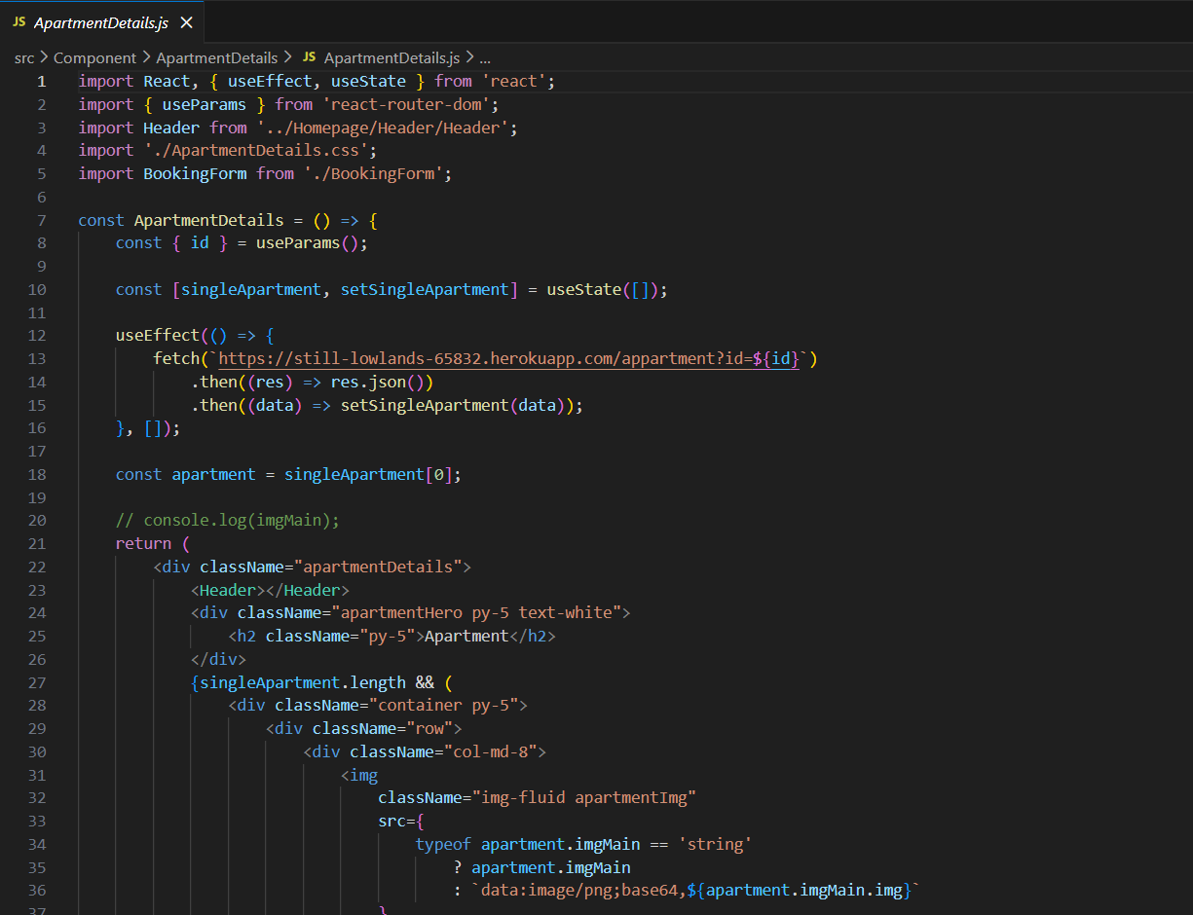

Figures represents the Apartment Details module of the application, which consists of the ApartmentDetails component, its corresponding styling files, and the BookingForm component. This module is responsible for displaying detailed information about a selected apartment and allowing users to place a booking request.
The ApartmentDetails component retrieves the apartment ID from the URL using dynamic routing. When the component loads, it sends a request to the backend server to fetch the specific apartment data based on the provided ID. The fetched data is stored in the component state and rendered dynamically on the page. Conditional rendering ensures that the apartment details are displayed only after the data is successfully retrieved.
The page layout includes a reusable header section, a hero banner with a background image and title, the main apartment image, and detailed apartment information. The component supports flexible image rendering by handling both direct image URLs and encoded image formats.
The BookingForm component is integrated within the apartment details page to allow users to submit booking information. It uses state management to capture user inputs such as name, phone number, email, and message. The form also includes apartment-related details such as apartment name, address, and price. Upon submission, the booking data is sent to the backend server using a POST request for processing and storage.
The styling of this module is handled using CSS/SCSS files, which define layout structure, background styling, flexbox alignment, image sizing, and typography. The use of SCSS mixins improves code reusability and maintains consistent design throughout the component.
Overall, the Apartment Details module demonstrates dynamic routing, API integration, state management, conditional rendering, form handling, and structured styling, making it a key feature of the apartment booking system.

Referral Image:

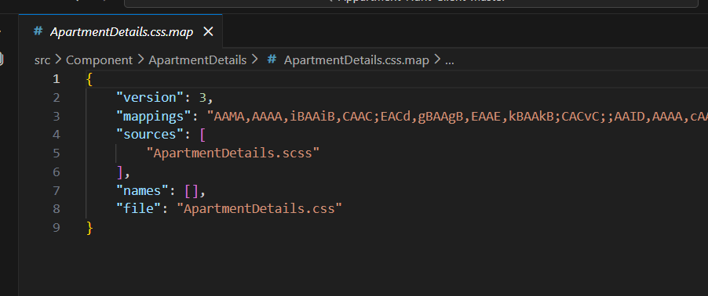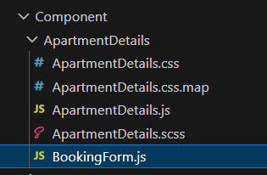

5.5 Dashboard Module
the Dashboard module of the application. This module is designed to manage both administrative and user functionalities within the apartment booking system. It is structured into multiple subcomponents to ensure clear separation of responsibilities and better maintainability.
The Dashboard module includes components such as AddApartment, AdminDashboard, AdminSidebar, DashboardTitle, MyRent, UserDashboard, and UserSidebar. Each component serves a specific purpose within the system.
The AdminDashboard provides administrative control over the application, allowing the admin to manage apartments, bookings, and related operations. The AddApartment component enables the administrator to add new apartment listings to the system. The AdminSidebar offers structured navigation options for administrative tasks.
On the user side, the UserDashboard allows users to view and manage their booking activities. The MyRent component displays the rental or booking details associated with the logged-in user. The UserSidebar provides navigation links for user-specific actions and pages.
The DashboardTitle component ensures consistent page headings and improves the overall layout structure across different dashboard views.
Overall, the Dashboard module organizes administrative and user functionalities into separate, well-structured components. This modular design improves scalability, readability, and maintainability of the apartment booking system while providing a clear and user-friendly interface for both administrators and users.

Referral Image:

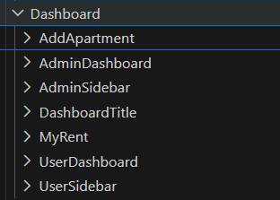
5.5.1 Add Apartment Component
The component utilizes React hooks for state management and context handling. The UserContext is used to access the currently logged-in user information, ensuring that only authorized users (such as administrators) can perform apartment addition tasks.
The component maintains state variables to store apartment details and the uploaded image file. The apartment information includes fields such as apartment name, service charge, flat size, number of baths, short summary, price, address, security deposit, and number of bedrooms. These fields are managed using state to capture user input dynamically.
A form interface is provided for entering all required apartment details. The form ensures structured data collection and improves usability for administrators. Additionally, the component handles file uploads for the apartment image, enabling visual representation of the property.
Once the form is submitted, the entered data is processed and sent to the backend server for storage in the database. This ensures that newly added apartments become available for viewing and booking within the system.
Referral Image:

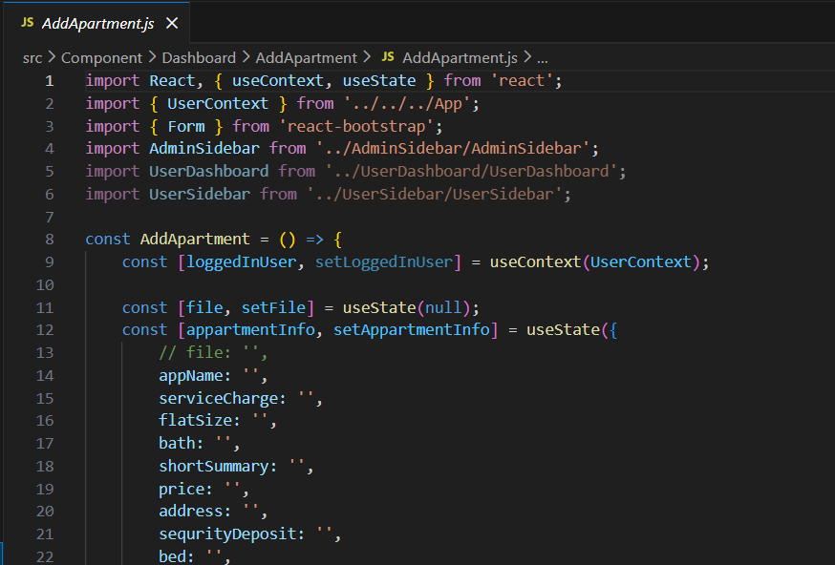

5.5.2 Admin Dashboard Component
the AdminDashboard component of the Dashboard module. This component is responsible for managing and monitoring booking activities within the apartment booking system from the administrator’s perspective.
The component uses React hooks for state and lifecycle management. The UserContext is utilized to access information about the currently logged-in user, ensuring that dashboard access is restricted to authorized administrators.
The Admin Dashboard retrieves booking data from the backend server when the component loads. This is achieved through an API request that fetches the complete list of bookings stored in the system. The retrieved data is saved in the component state and displayed dynamically on the dashboard.
The layout includes the AdminSidebar component, which provides structured navigation for administrative tasks. The main content area displays booking details in an organized format, allowing the administrator to review user bookings efficiently.
Referral Image:

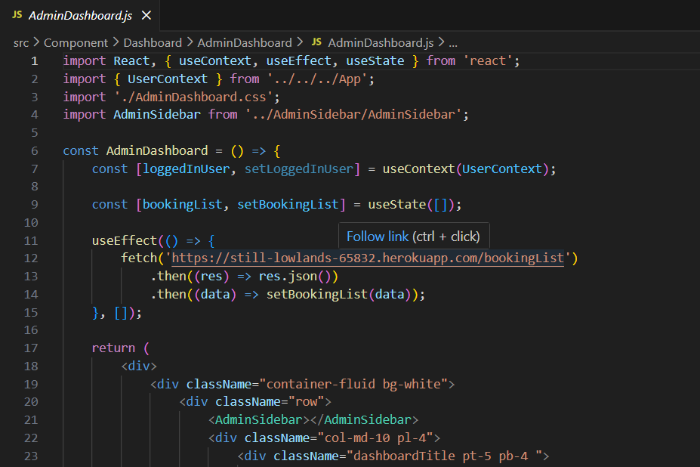

5.5.3 Admin Sidebar Component

the AdminSidebar component, which provides navigation and account management features for administrators within the Dashboard module.
This component is responsible for displaying the sidebar menu on the admin dashboard. It includes navigation links that allow the administrator to access different dashboard sections such as adding apartments and viewing booking details. The sidebar ensures smooth navigation between administrative functionalities.
The component integrates icon support using a font icon library to enhance the visual appearance of menu items. It also displays the application logo at the top of the sidebar, maintaining brand identity within the dashboard interface.
The UserContext is used to access information about the currently logged-in administrator. The component includes a logout functionality implemented through Firebase authentication. When the administrator signs out, the user session is cleared, authentication tokens are removed from session storage, and the user state is reset. This ensures secure logout and prevents unauthorized access.

Referral Image:

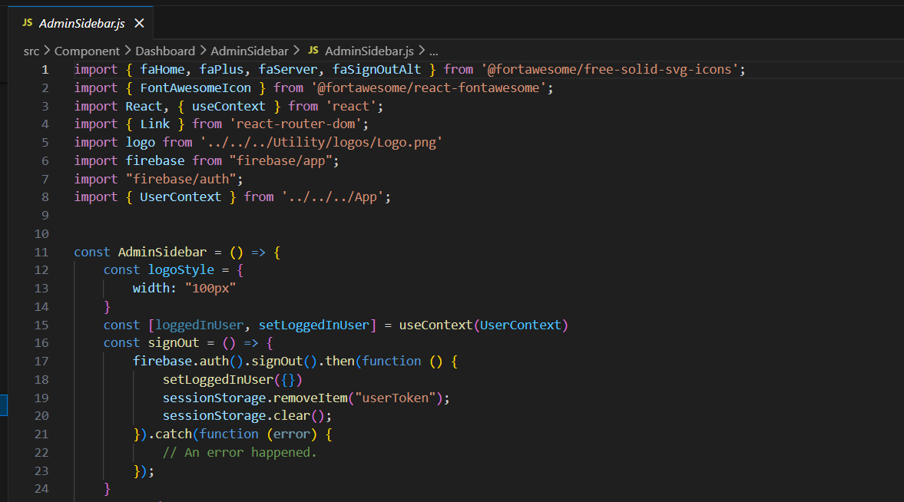

5.5.4 Dashboard Title Component
The DashboardTitle component is responsible for displaying the header section within the dashboard layout. It provides a consistent and structured title area across different dashboard pages, improving visual organization and user experience.
This component accepts a dynamic title as a property, allowing different dashboard sections to display relevant headings. It ensures uniform styling and alignment for all dashboard pages.
The component also integrates the application logo, which redirects users to the home page when clicked. The UserContext is used to access information about the currently logged-in user, enabling personalized display or future role-based enhancements.
Styling for this component is handled through a dedicated CSS file, ensuring proper layout alignment, spacing, and responsiveness.

Referral Image:

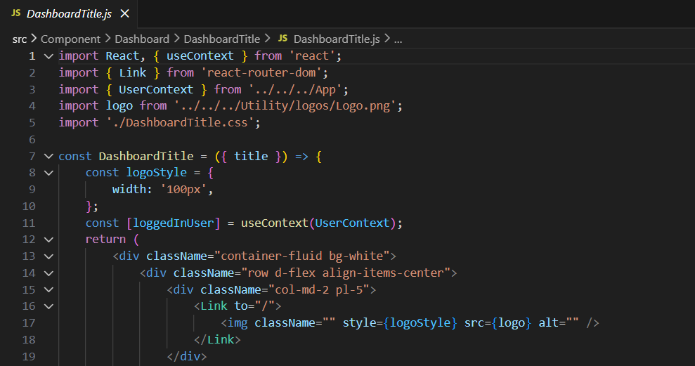
5.5.5 My Rent Component
The MyRent component is designed to display booking or rental details associated with the currently logged-in user. It is part of the user dashboard module and provides users with a personalized view of their rental information.
This component uses React hooks for state and lifecycle management. The UserContext is utilized to access the logged-in user’s information, particularly the user’s email address. When the component loads, it sends a request to the backend server to retrieve rental data corresponding to that email.
The fetched data is stored in the component state and rendered dynamically on the page. This ensures that users can view their specific booking details, such as apartment name, address, and rental status.
The layout integrates the UserSidebar component to provide navigation options within the user dashboard. Styling is managed through a dedicated CSS file to maintain proper structure, spacing, and responsiveness.

Referral Image:

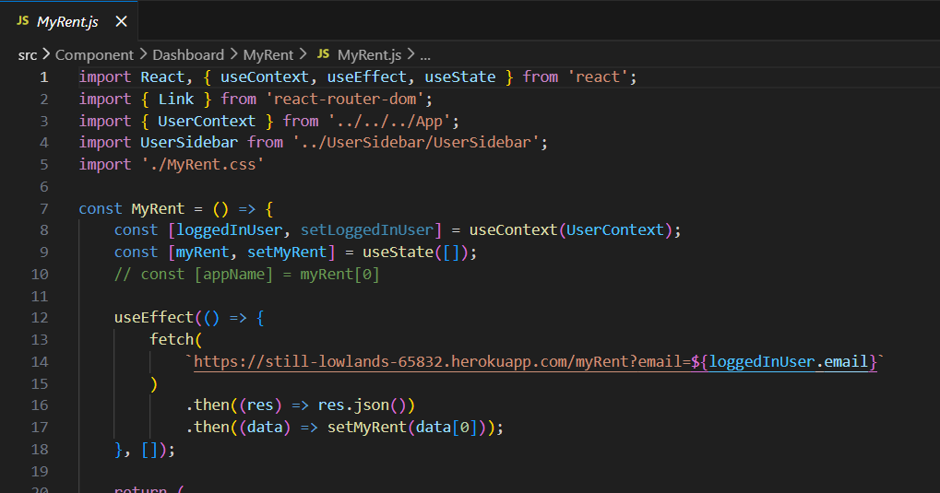

5.5.6 User Dashboard Component
The UserDashboard component provides the main dashboard interface for regular users within the apartment booking system. It serves as the central layout for user-specific activities and information.
This component uses the UserContext to access details of the currently logged-in user. By retrieving user information from context, the dashboard can display personalized content, such as the user’s email or account details.
The layout is structured using a responsive grid system. It integrates the UserSidebar component, which offers navigation links for user-related sections such as rental details and other account features. The main content area displays the dashboard title and user-specific information in a clean and organized format.
Conditional rendering is applied to ensure that certain user details are shown only when valid login information is available. Styling is handled through appropriate CSS classes to maintain consistent spacing, alignment, and responsiveness.

Referral Image:

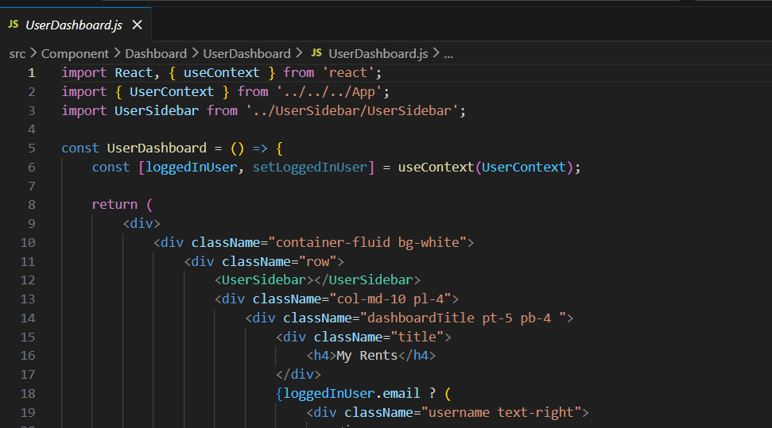

5.5.7 User Sidebar Component
The UserSidebar component provides navigation functionality for users within the dashboard section of the application. It ensures that users can easily access different dashboard features in a structured and user-friendly manner.
This component integrates icon support using a font icon library to visually enhance the sidebar menu options. It also displays the application logo at the top, which serves as a clickable link redirecting users to the home page.
The component uses UserContext to access information about the currently logged-in user. It includes a logout feature implemented using Firebase authentication. When a user signs out, the system clears the user session, removes authentication tokens from session storage, and resets the user state to maintain security.
The sidebar contains navigation links to user-specific sections such as the main dashboard and rental details. The layout is styled to maintain consistent spacing, alignment, and responsiveness across different screen sizes.

Referral Image:

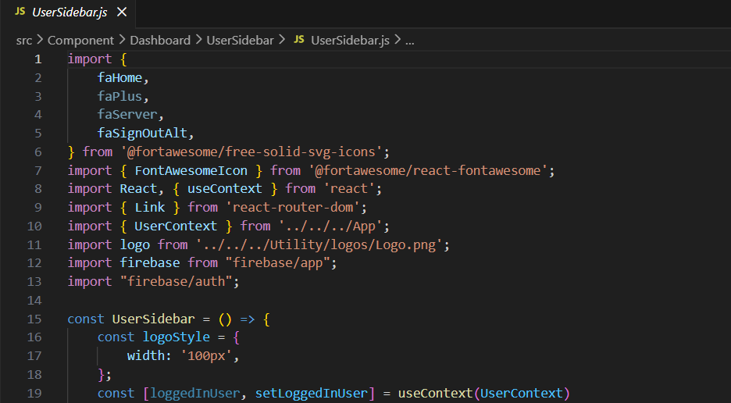

5.6 Error Component
The Error component is designed to handle invalid routes and unexpected navigation within the apartment booking system. It ensures that users are presented with a clear and user-friendly message whenever they attempt to access a page that does not exist or encounter a routing error.
This component acts as a fallback route in the application’s routing configuration. When a user navigates to an undefined URL, the Error component is rendered automatically. It typically displays an appropriate error message, such as “Page Not Found,” along with navigation options to return to the home page or another valid section of the application.
The Error component improves user experience by preventing blank screens and providing clear guidance during navigation issues. It also enhances application reliability by managing routing errors in a structured and controlled manner.

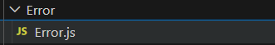

The UserSidebar component is a navigation panel designed specifically for users within the dashboard module. It provides structured access to different user-related sections of the apartment booking system.
This component incorporates icon support through a font icon library to enhance the visual presentation of menu options. The application logo is displayed at the top of the sidebar and serves as a clickable link that redirects users to the home page.
The component uses UserContext to access the currently logged-in user’s information. It includes a secure logout feature implemented using Firebase authentication. When a user chooses to sign out, the system clears authentication data, removes stored session tokens, and resets the user state to ensure secure session termination.
The sidebar contains navigation links to user dashboard sections such as rental details and other account-related features. The layout is styled to maintain consistent alignment, spacing, and responsiveness across various screen sizes.

Referral Image:

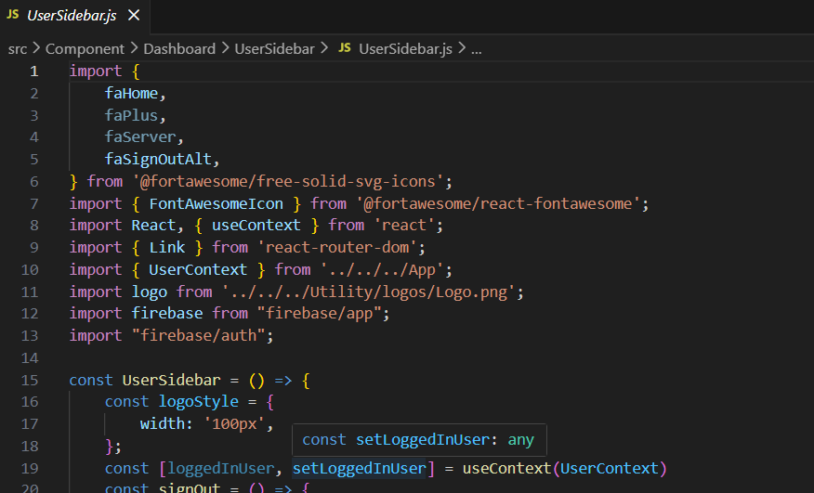

5.7 Fake Data Module
The FakeData module contains sample apartment data used for development and testing purposes within the application. This module exports an array of apartment objects that simulate real database records.
Each apartment object includes detailed attributes such as apartment ID, apartment name, address, number of bedrooms, number of bathrooms, price, service charge, security deposit, flat size, and a short summary description. It also contains image URLs for the main apartment image and additional preview images.
This mock data allows developers to design and test UI components such as apartment listings, detail pages, and booking features without requiring a live backend connection. By using structured sample data, the development process becomes faster and more efficient.
Referral Image:

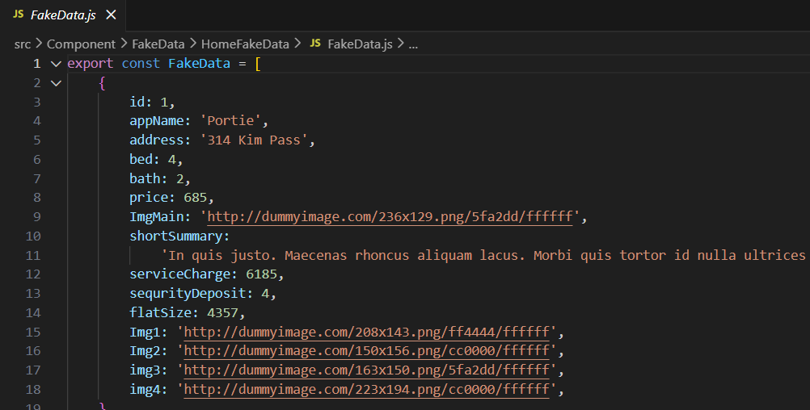
5.7 Homepage Components Structure
The Homepage folder contains all the main components required to build the landing page of the application. Each component is separated to maintain a clean structure, reusability, and better code organization.
Referral Image:

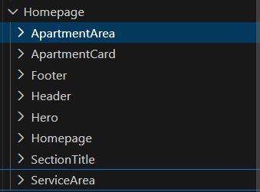

1. Homepage
This is the main container component that combines all homepage sections together. It imports and renders other components like Header, Hero, ApartmentArea, ServiceArea, and Footer in proper order.
Referral Image:

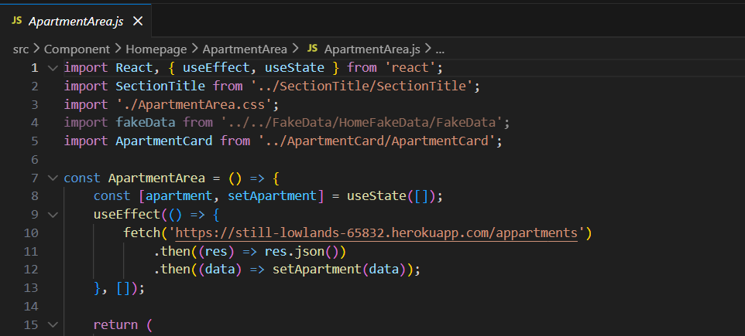

2. Header
The Header component contains the top navigation bar of the website. It typically includes the logo, navigation links, and authentication options (login/logout).
Referral Image:

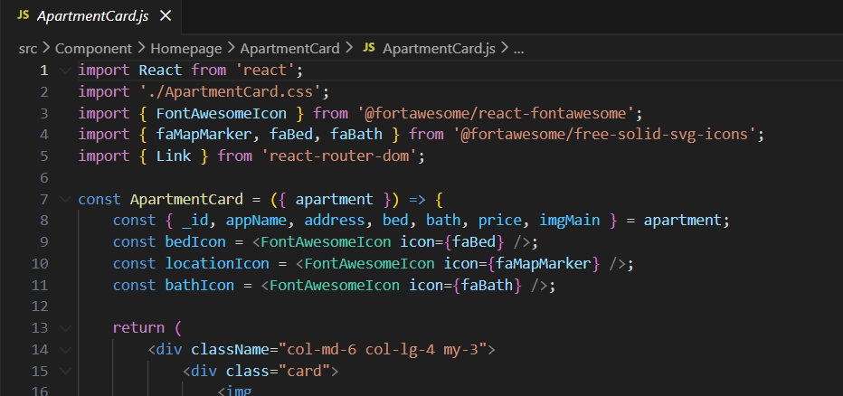

3. Hero
The Hero section is the main banner area displayed at the top of the homepage. It usually contains a background image, heading text, and a call-to-action button to attract users.

Referral Image:

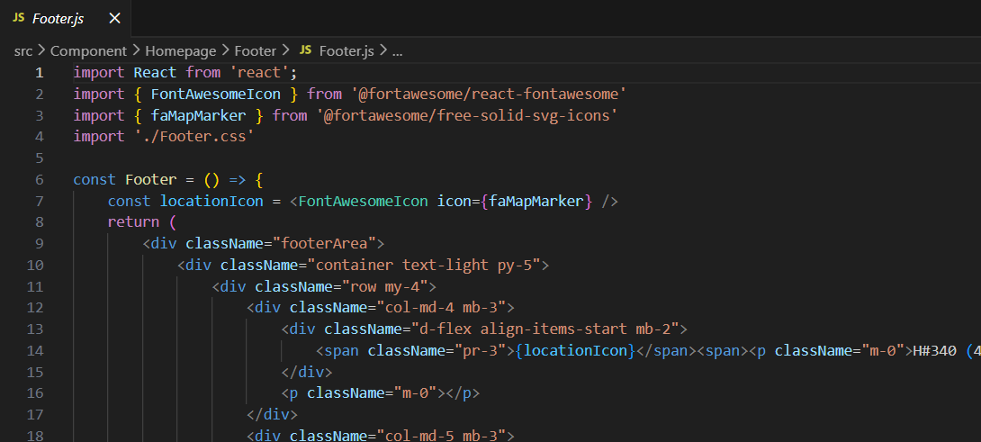

4. ApartmentArea
This component displays available apartments. It fetches data (such as from FakeData) and renders multiple ApartmentCard components dynamically.
Referral Image:

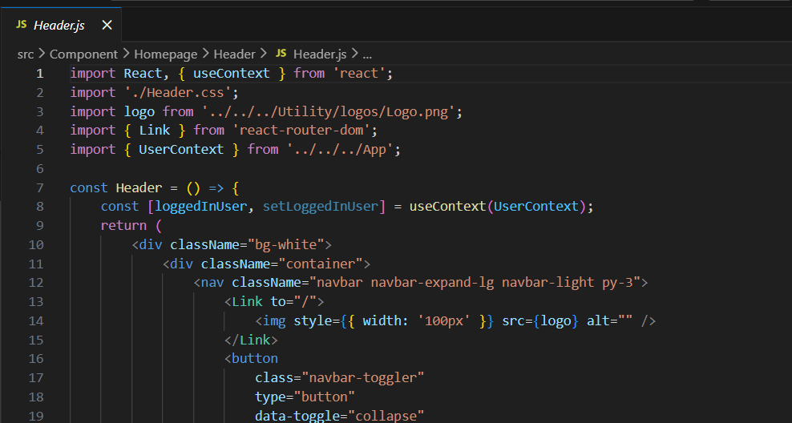

5. ApartmentCard
ApartmentCard is responsible for displaying individual apartment details such as image, name, address, price, and basic information. It is reusable and receives data via props.
Referral Image:

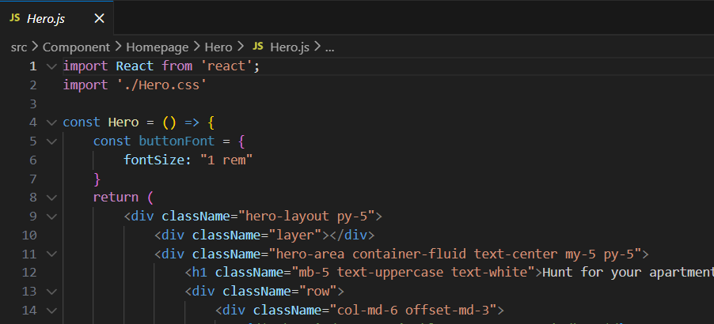

6. SectionTitle
This component is used to display section headings in a consistent design format across different sections of the homepage.
Referral Image:

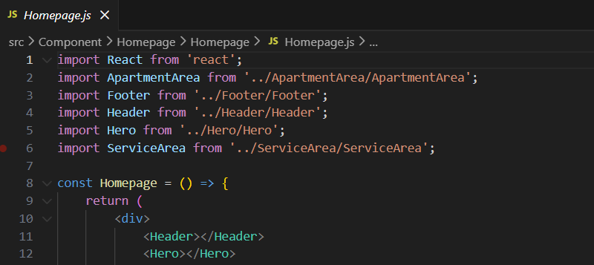

7. ServiceArea
The ServiceArea component presents services offered by the platform, such as booking support, security, or maintenance features.
Referral Image:

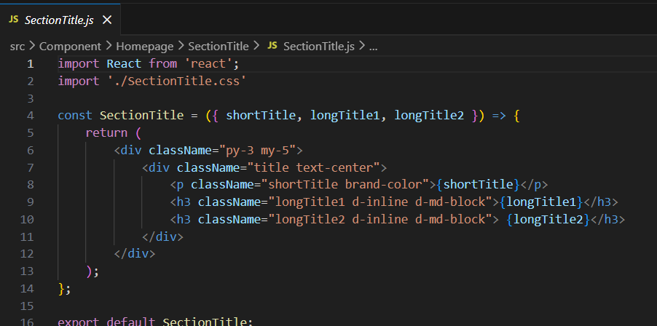

8. Footer
The Footer component appears at the bottom of the homepage. It usually contains contact information, quick links, social media links, and copyright details.
Referral Image:

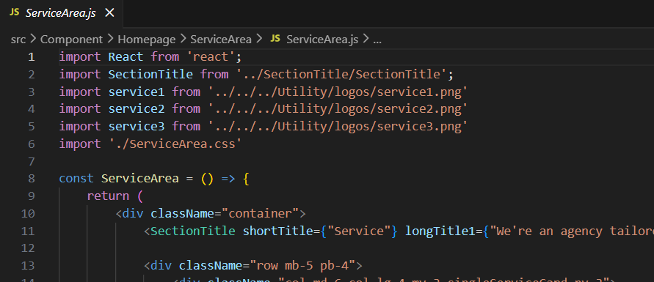

5.8 Login Module Structure
The Login folder contains all files related to user authentication and login functionality of the application. This module handles user sign-in and integrates with Firebase authentication services.

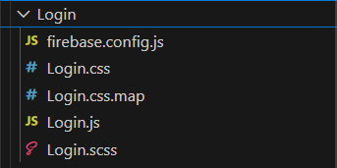
1. firebase.config.js
This file contains the Firebase configuration settings required to connect the application to the Firebase project. It includes API keys, project ID, authentication domain, and other necessary credentials. This configuration enables authentication and other Firebase services.

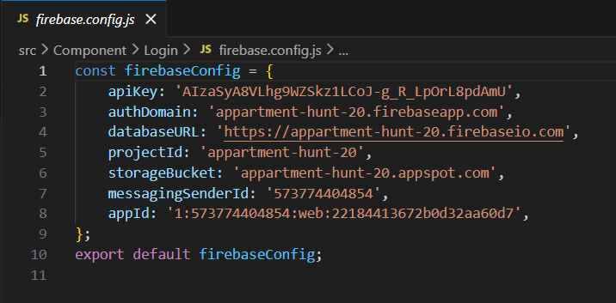

2. Login.js
The Login component manages the login functionality. It handles user authentication using Firebase, processes login credentials, and updates the user context after successful login. It may support different authentication methods such as email/password or third-party providers.

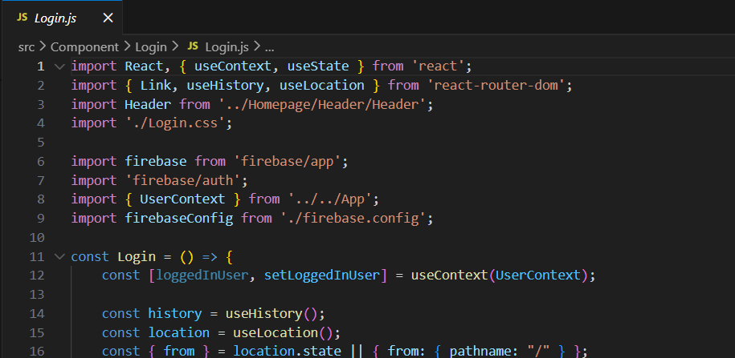

3. Login.css / Login.scss
These files are used for styling the login page.
- Login.css contains standard CSS styles for layout and design.
- Login.scss allows the use of advanced styling features such as variables, nesting, and reusable style structures.
- The Login.css.map file helps in debugging styles by mapping compiled CSS back to SCSS source code.
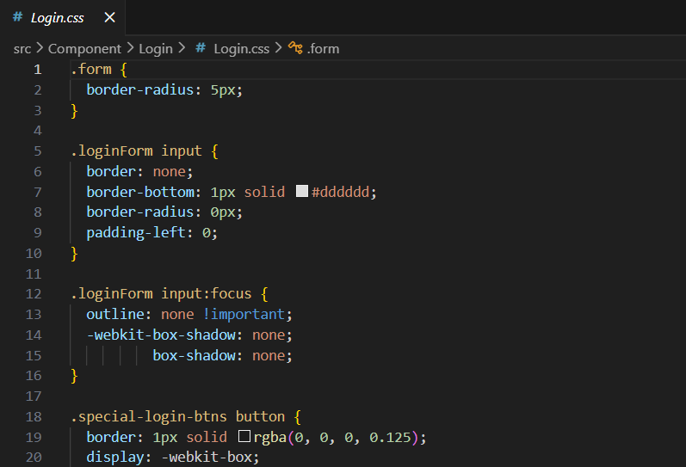

5.9 PrivateRoute Module
The PrivateRoute folder contains the component responsible for protecting restricted routes in the application.

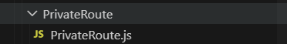

PrivateRoute.js
The PrivateRoute component ensures that only authenticated users can access certain pages, such as the User Dashboard or booking pages.
It works by checking whether a user is logged in (usually through UserContext or Firebase authentication).
- If the user is authenticated, the component allows access to the requested route.
- If the user is not authenticated, the component redirects the user to the Login page.
This improves the security of the application by preventing unauthorized access to protected pages.

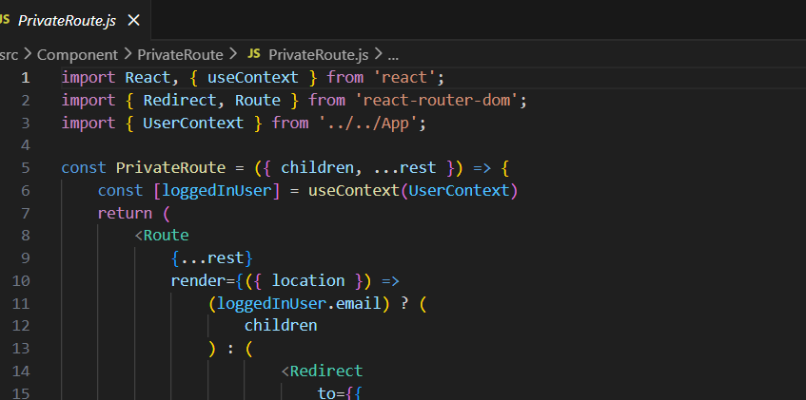

5.10 Signup Module
The Signup folder contains the component responsible for user registration in the application.

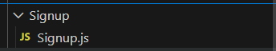
Signup.js
The Signup component allows new users to create an account in the system. It collects user information such as name, email, and password through a registration form.
After form submission, the component connects with Firebase Authentication to create a new user account. Once registration is successful, the user data is stored and the application may redirect the user to the dashboard or login page.
The Signup component also handles validation and error messages to ensure proper input from users.

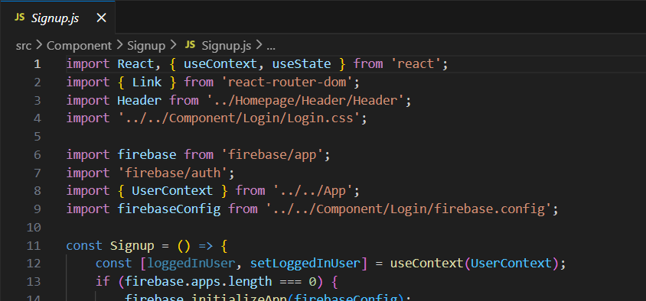
5.11 Root Project Files Structure
The following files are located in the main project directory and are essential for configuring, running, and maintaining the React application.

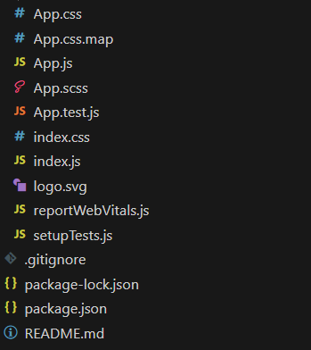

1. App.js
This is the main component of the application. It controls routing, layout structure, and integrates major components such as Homepage, Login, Signup, Dashboard, and PrivateRoute.

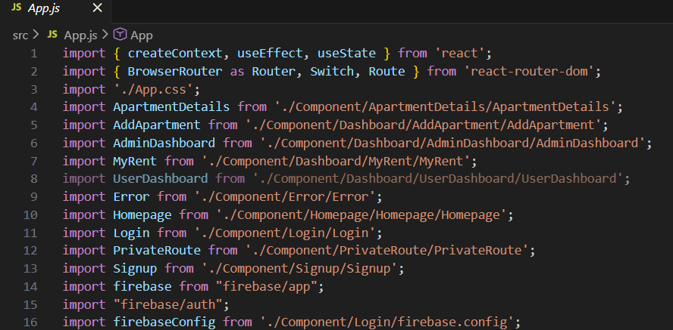

2. App.css / App.scss
These files contain global styles applied to the application.
- App.css includes standard CSS styling.
- App.scss allows advanced styling features like variables and nesting.
- App.css.map helps in debugging SCSS by mapping compiled CSS back to the source file.

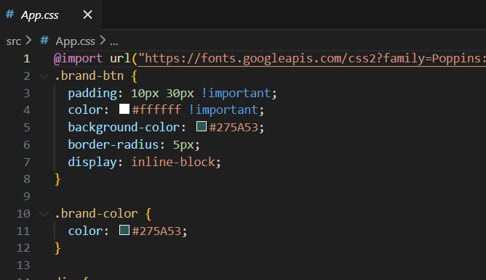

3. index.js
This is the entry point of the React application. It renders the App component into the root DOM element and initializes the entire frontend application.

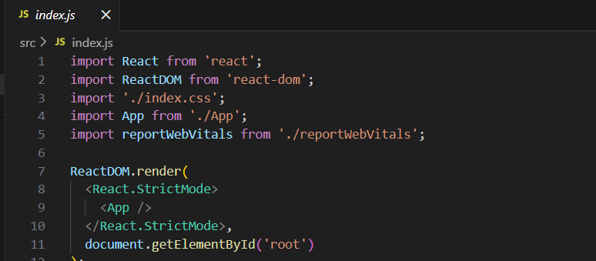
4. index.css
This file contains base-level styling such as body formatting, font settings, and default layout adjustments.

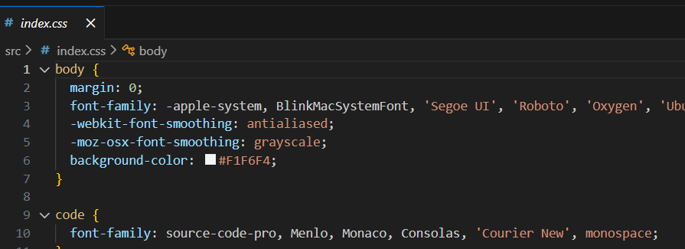

5. App.test.js
This file is used for testing the App component. It ensures that components render correctly and basic functionality works as expected.

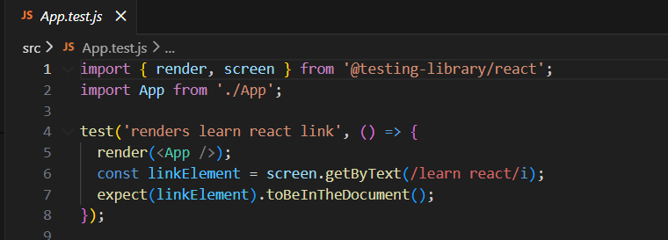

6. reportWebVitals.js
This file is used to measure and report application performance metrics such as load time and responsiveness.

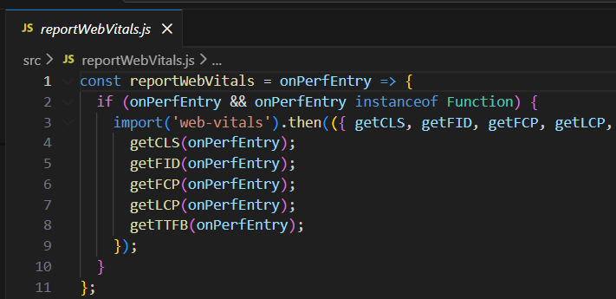

7. setupTests.js
This file is used to configure the testing environment for the application.

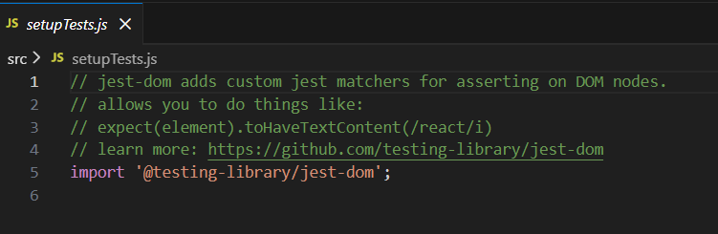
CHAPTER 6
FUNCTIONAL AND PERFORMANCE TESTING

Functional and Performance Testing ensures that the application works correctly according to the requirements and performs efficiently under different conditions.

6.1 Functional Testing
operate as expected. Each module was tested individually and then integrated testing was performed.
The following functionalities were tested:
- User Registration (Signup)
- User Login and Authentication using Firebase
- Private Route access control
- Display of apartment listings
- Viewing apartment details
- Dashboard access for logged-in users
- Logout functionality
All forms were tested for proper validation, including empty fields, incorrect email formats, and password constraints. Navigation between pages was verified to ensure smooth routing without errors.
The results confirmed that all core functionalities are working correctly and meet the specified requirements.

6.2 Performance Testing
Performance testing was performed to evaluate the responsiveness and efficiency of the application.
The following aspects were tested:
- Page load time
- Rendering speed of apartment listings
- Authentication response time
- Routing performance between pages
The application showed fast loading speed due to React’s component-based architecture and optimized rendering. Firebase authentication responded quickly during login and signup operations.
The system performed efficiently under normal usage conditions without crashes or delay

6.3 Security Testing
Security testing was conducted to ensure that the application protects user data and prevents unauthorized access.
The following security aspects were verified:
- Authentication using Firebase to ensure secure login and signup.
- Password protection and validation rules.
- Private route protection to restrict access to authorized users only.
- Prevention of unauthorized dashboard access without login.
- Proper logout functionality to terminate user sessions.
User credentials are handled securely through Firebase Authentication, which reduces risks related to password storage and encryption. Additionally, protected routes ensure that sensitive pages cannot be accessed directly through URL manipulation.

CHAPTER 7
RESULTS

7.1 Output Screenshot – Homepage
The above screenshot represents the Homepage of the Apartment Hunt web application.
The homepage contains the following key sections:
- Header Section:
Displays the project logo "Apartment Hunt" along with navigation links such as Home and Login. This allows users to easily navigate through the application.
- Hero Section:
The large banner image with the heading “HUNT FOR YOUR APARTMENT” serves as the main attraction of the webpage. It visually represents the purpose of the platform and creates a strong first impression for users.
- Apartment Section Introduction:
Below the hero section, the title “Discover the latest Rent available today” introduces the apartment listing area where users can explore available rental properties.
This output confirms that:
- The layout renders correctly.
- Navigation links are displayed properly.
- The UI design is clean, responsive, and user-friendly.
- The homepage successfully reflects the core objective of the project.

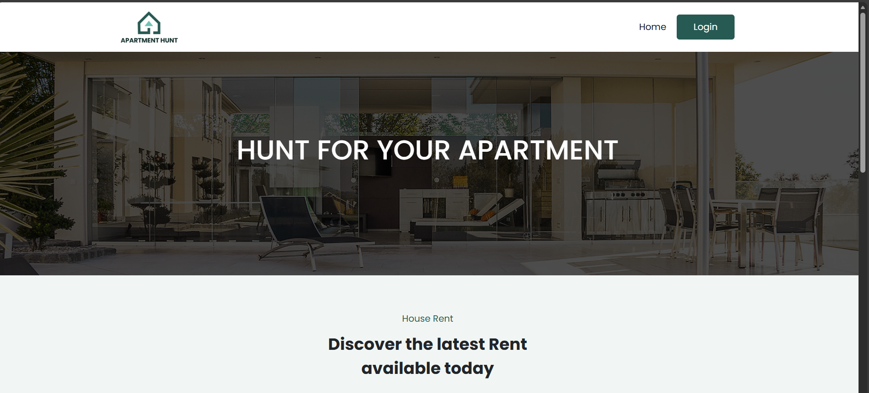

7.2 Output Screenshot – Service Section
The above screenshot represents the Service Section of the Apartment Hunt web application.
This section highlights the key services offered by the platform to users. It is designed to build trust and clearly communicate the benefits of using the application.
The section includes:
- Wide Range of Properties
Displays that the platform provides a large selection of rental properties. This assures users that they have multiple options to choose from based on their needs and preferences.
- Financing Made Easy
Indicates that the platform supports users with financial guidance or flexible solutions, making the rental process smoother and stress-free.
- Trusted by Thousands
Demonstrates credibility by showing that many users rely on the platform. This increases user confidence and platform reliability.
The clean layout, icons, headings, and short descriptions improve readability and user experience. The service section successfully communicates the value proposition of the application and enhances the professional appearance of the website.

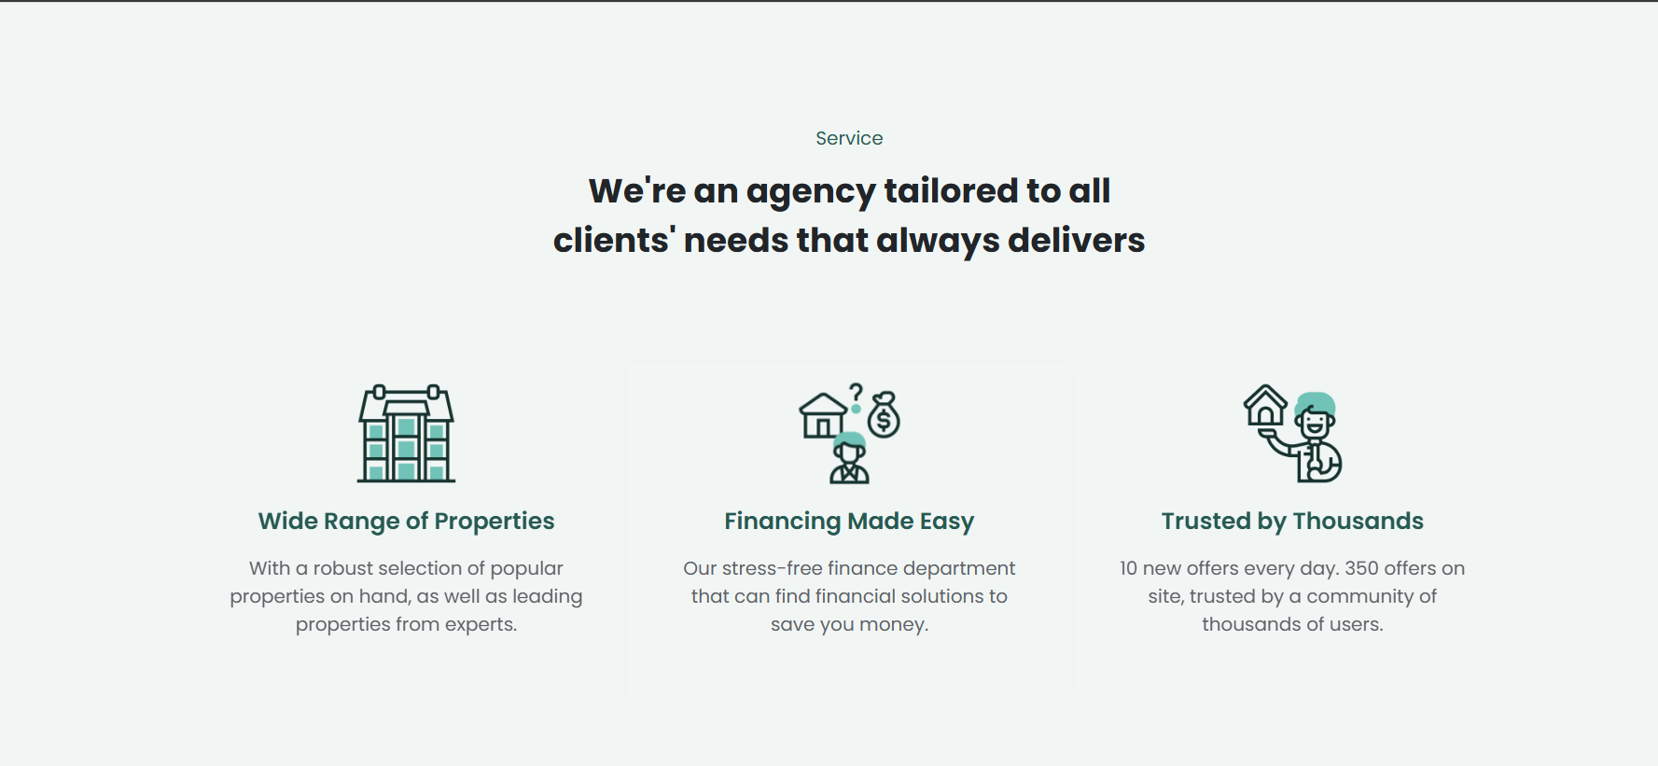

7.3 Output Screenshot – Login Page
The above screenshot represents the Login Page of the Apartment Hunt web application.
This page allows registered users to securely access their accounts.
The Login page contains the following elements:
- Login Title:
Clearly indicates that the page is for user authentication.
- Email Field:
Allows users to enter their registered email address.
- Password Field:
Allows users to enter their secure password.
- Forgot Password Option:
Provides users with the ability to recover their account if they forget their password.
- Login Button:
Submits the entered credentials for authentication using Firebase.
- Create Account Link:
Redirects new users to the Signup page if they do not have an account.
- Continue with Google Option:
Enables users to log in using Google authentication for a faster and more convenient login process.
The clean design, centered form layout, and clear call-to-action buttons enhance usability and user experience.

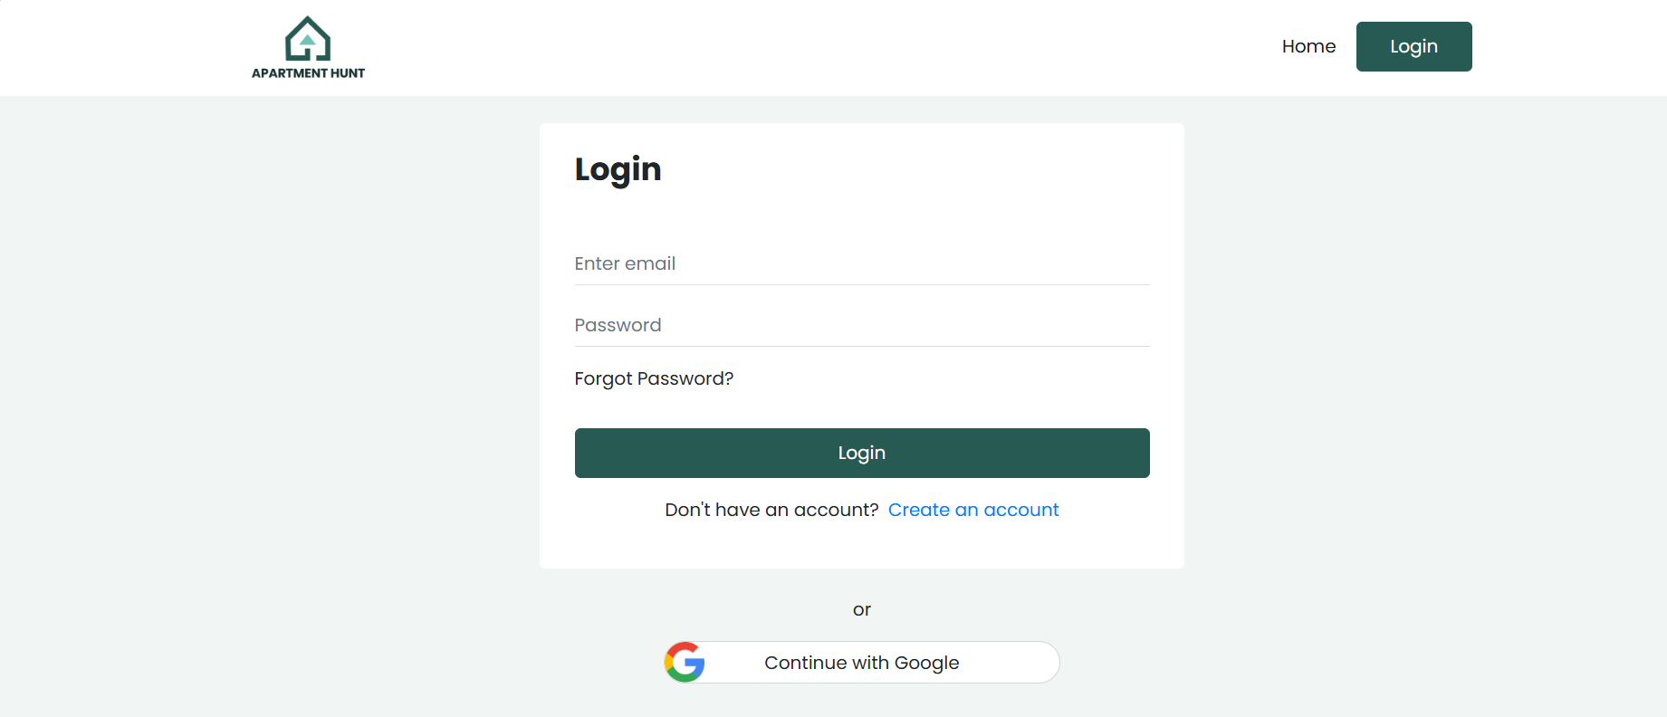

7.4 Output Screenshot – User Dashboard (My Rents Page)
The above screenshot represents the User Dashboard page titled “My Rents” in the Apartment Hunt web application.
This page is accessible only after successful login and is protected using PrivateRoute authentication.
The dashboard includes the following features:
- Sidebar Navigation:
  - My Rents
  - Go to Home
  - Logout
The sidebar allows users to navigate between their rental information and the homepage, and also provides a logout option.
- Main Content Area:
Displays the message “Please book an apartment”, indicating that no apartment has been booked yet.
- User Profile Display:
The top-right corner shows the logged-in user's name and profile picture, confirming successful authentication.
This output confirms that:
- The PrivateRoute protection is working correctly.
- Only authenticated users can access the dashboard.
- User details are successfully retrieved and displayed.
- The logout option is available for secure session termination.
The dashboard structure demonstrates proper routing, authentication integration, and component rendering within the application.

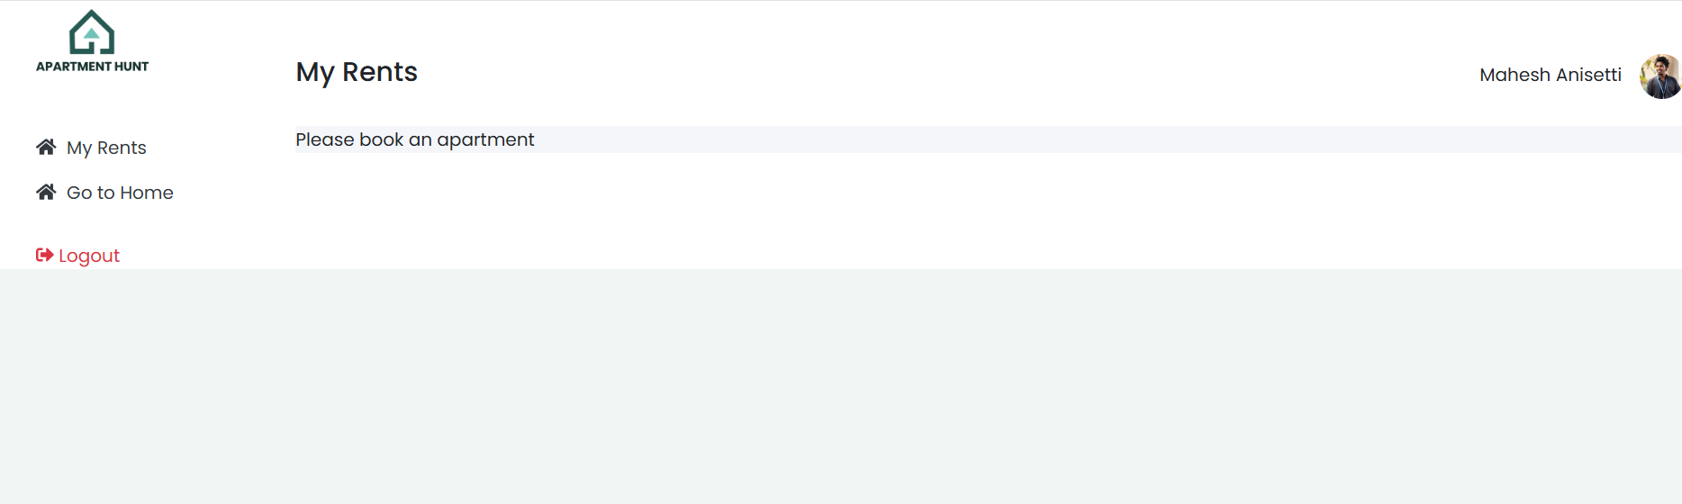

CHAPETR8
ADVANTAGES & DISADVANTAGES

This chapter explains in detail the strengths and limitations of the Apartment Rental Web Application developed in this project.

8.1 Advantages
1. Simple and User-Friendly Interface
The application is designed with a clean layout and clear navigation structure. Users can easily move between the Homepage, Login, Signup, and Dashboard without confusion. The structured sections such as Hero, Apartment Listings, and Services improve readability and overall user experience. Even first-time users can understand how to use the platform without guidance.
2. Secure Authentication System
The system uses Firebase Authentication for user login and registration. This ensures secure handling of user credentials. Passwords are not stored manually in the application, which reduces the risk of data breaches. Google Sign-In functionality further enhances convenience and security.
3. Protected Routes for Security
PrivateRoute implementation ensures that only authenticated users can access sensitive pages like the User Dashboard. If an unauthorized user tries to access restricted pages, they are automatically redirected to the Login page. This improves access control and protects user-specific information.
4. Component-Based Development
The project is built using React’s component-based architecture. Each section (Header, Hero, ApartmentCard, ServiceArea, Dashboard, etc.) is developed as a separate component. This improves code readability, reusability, maintainability, and scalability. Future developers can easily modify or extend individual components without affecting the entire system.
5. Fast Performance and Responsiveness
React ensures efficient rendering using the virtual DOM, which improves performance. The application loads quickly and provides smooth page navigation. The UI is responsive and adapts to different screen sizes, making it suitable for desktops and mobile devices.
6. Organized Project Structure
The folder structure is well organized (Homepage, Login, Signup, PrivateRoute, Dashboard, etc.). This makes the project easy to understand, maintain, and upgrade in the future.
7. Easy Scalability
The current architecture allows easy integration of additional features such as:
- Online payment gateway
- Real-time database integration
- Admin panel
- Booking confirmation system
- Chat support system

8.2 Disadvantages
1. No Real-Time Database Integration
Currently, the apartment listings are based on static or fake data. The system does not yet connect to a real-time backend database to store and retrieve apartment information dynamically.
2. Limited Booking Functionality
Although the dashboard exists, the actual booking process is not fully implemented. Users cannot complete a real apartment booking or store booking history in the database.
3. No Payment System
The application does not include online payment integration. Users cannot pay rent or booking fees through the platform.
4. Basic Admin Control
There is no admin panel to manage apartment listings, user accounts, or booking approvals. All data is predefined in the frontend.
5. Dependence on Internet Connection
Since the application relies on Firebase and web technologies, it requires an active internet connection to function properly.
6. Limited Error Handling
Advanced error handling and user activity tracking are not fully implemented. More detailed feedback messages and logging systems could improve reliability.

CHAPTER9
CONCLUSION

The Apartment Rental Web Application developed in this project successfully achieves its primary objective of building a modern, secure, and user-friendly rental platform. The system was designed to simplify the process of searching for rental apartments and managing user access through authentication and protected routing.
The project demonstrates the practical implementation of frontend development concepts using React, including component-based architecture, state management, routing, and reusable UI structures. Each module—Homepage, Apartment Listings, Services Section, Login, Signup, PrivateRoute, and User Dashboard—was carefully designed and integrated to ensure smooth functionality and logical flow.
Firebase Authentication was successfully integrated to provide secure user registration and login functionality. The use of PrivateRoute strengthened application security by ensuring that only authenticated users can access restricted pages such as the dashboard. This shows the proper implementation of authentication flow and access control mechanisms.
From a performance perspective, the application provides fast loading times and smooth navigation due to React’s virtual DOM and optimized rendering. The organized folder structure and modular design make the project scalable and easy to maintain. Future improvements can be implemented without restructuring the entire system.
The project also highlights important software development phases, including requirement analysis, design planning, implementation, testing, and evaluation. Functional and performance testing confirmed that the core features are working correctly and reliably.
Although the current system uses static apartment data and does not include advanced features such as payment integration, booking storage, or an admin management system, it provides a strong foundation for further development. The architecture supports future enhancements like:
- Real-time database integration
- Online payment gateway
- Booking history management
- Admin dashboard for property management
- User profile management
- Advanced search and filter options
In conclusion, the Apartment Rental Web Application is a successful academic project that effectively demonstrates knowledge of modern web technologies, authentication systems, routing, and user interface design. With further development and backend integration, this system can evolve into a fully functional and commercially viable rental management platform.

CHAPTER10
FUTURE ENHANCEMENTS

This chapter discusses the possible improvements and additional features that can be implemented in future versions of the Apartment Rental Web Application.
Although the current system successfully implements core functionalities such as authentication, apartment viewing, and protected dashboards, several advanced features can be added to make the platform more complete and commercially viable.
10.1 Real-Time Database Integration
The current version uses static or mock data for apartment listings. In the future, a real-time database such as Firebase Firestore or MongoDB can be integrated to dynamically store and retrieve apartment details, booking records, and user information.
10.2 Online Booking System
A complete booking system can be implemented where users can select dates, confirm bookings, and store booking history in the database. This would make the platform more practical and interactive.
10.3 Payment Gateway Integration
Integration of secure online payment gateways such as Razorpay, Stripe, or PayPal would allow users to pay rent or booking fees directly through the application. This would significantly enhance the usability of the system.
10.4 Admin Management Panel
An advanced admin dashboard can be developed to:
- Add, update, and delete apartment listings
- Manage user accounts
- Approve or reject bookings
- Monitor transactions
This would improve system control and management efficiency.
10.5 Advanced Search and Filter Options
Users can be provided with filtering options based on:
- Price range
- Location
- Number of bedrooms
- Amenities
This would enhance user experience and help users find apartments more efficiently.
10.6 User Profile Management
Users can be allowed to update personal details, change passwords, upload profile pictures, and view booking history.
10.7 Email and Notification System
Automatic email confirmations and in-app notifications can be implemented for:
- Successful registration
- Booking confirmation
- Payment receipt
- Account updates
10.8 Mobile Application Development
A mobile version of the application can be developed using React Native to increase accessibility and reach more users.

CHAPTER11
REFERENCES

This chapter lists the references and resources used during the development of the Apartment Rental Web Application.
- React Official Documentation.
Available at: https://react.dev
Used for understanding component-based architecture, hooks, routing, and state management.
- Firebase Official Documentation.
Available at: https://firebase.google.com
Used for implementing authentication and managing secure user login/signup functionality.
- React Router Documentation.
Used for implementing navigation and protected routes within the application.
- Node.js Official Website.
Used for managing the development environment and package installation.
- Visual Studio Code Documentation.
Used as the primary code editor for writing and managing the project files.
- GitHub Documentation.
Used for version control and project repository management.
- Online Tutorials and Learning Platforms:
  - YouTube
  - W3Schools
  - Stack Overflow
These resources provided guidance on React development, Firebase authentication, routing implementation, UI design, and debugging during the project development process.

